Getting a plugin support license key

You are a reseller/partner
A/ Once the plugin is installed, at the end of the “Pro Distribution” section, click directly on the Register the plugin. This is a special additional service that let reseller/partners directly obtain a new key from a distributor without interactive process with the distributor's sales department. You will need to be registered as an agreed reseller/partner in your distributor's sales system.
B/ First step :
- Enter the distributor code : apl
- Enter your partner code : It was delivered to you by your distributor (at the moment ActiveProLearn)
- Validate
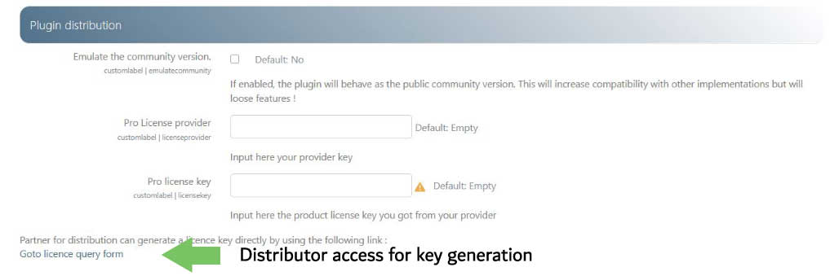
C/ Second step :
- Select the license option: on most cases Setup (or renewal year n+1)
- Validate.

- The TMA activation code is saved in the plugin and the “Pro” version is available (a green checkmark must appear at right side of the license field).

Use of the plugin on multiple separate Moodle instances
It is possible to obtain a validity extension of your activation codes on several instances, for example to allow full operation on a test or qualification domain. Contact us to register the ancillary domains.
This possibility is also suitable for deploying the plugin on several production areas, depending on the license agreements you benefit from. In this case, the same key is valid across all your domains.

You get the plugin directly from ActiveProLearn
Once the plugin is installed, in the “Plugin Distribution” section of the central settings of the plugin,
- Enter the supplier code : apl
- Enter the activation key (the key will have been communicated to you by APL)
- Validate.
- The TMA activation code is saved in the plugin and the “Pro” version is available (a green checkmark must appear to the right of the license field).

You get the plugin from a redistributor
Once the plugin is installed, in the “Distribution of the plugin” section of the central settings of the plugin,
- Enter the supplier code and the activation key (they were communicated to you by your distributor)
- Validate.
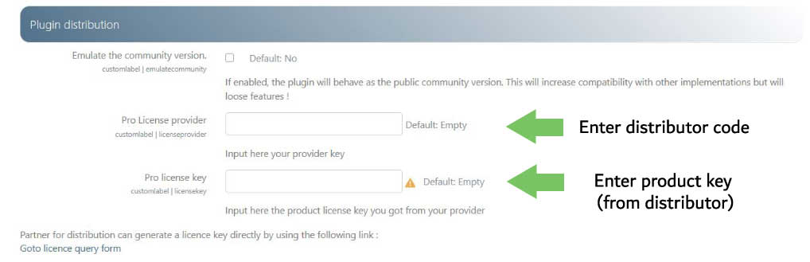
The TMA activation code is saved in the plugin and the “Pro” version is available (a green checkmark must appear to the right of the license field).
Back to general index

