Zabbix Moodle report

Presentation
This Zabbix report plugin schedules indicators values sedning to a Zabbix server. Zabbix is an opensource tool able to store and historicise values, plot graphs and build dashboards assembling numerous widgets and information.
The recollection of values is optimized for each indicator, so that it is emitted at a suitable frequency, according to its own variability. Thus we can optimize the database sollicitation for any data acquisition.
The solution is highly scalable, accepts easy to design extensions, add customized trackers, and assemble indicators in customized dashboards on a very flexible way.
Zabbix's “automated discovery” can discover measurements on data contexts that are built by usage.
The solution provides recollection models to integrate into the Zabbix server to help quick setup and configuration.
In addition, the plugin copes needs of Moodle service operators, so they can provide their customers a flexible way to access to valuable dashboards and data on a single Zabbix instance.
During this project, we could explore and exploit new Zabbix possibilities of adding customized widgets, so we can continuously improve data visualization (heatmaps, status grids, data distribution, indicator correlation, etc.).
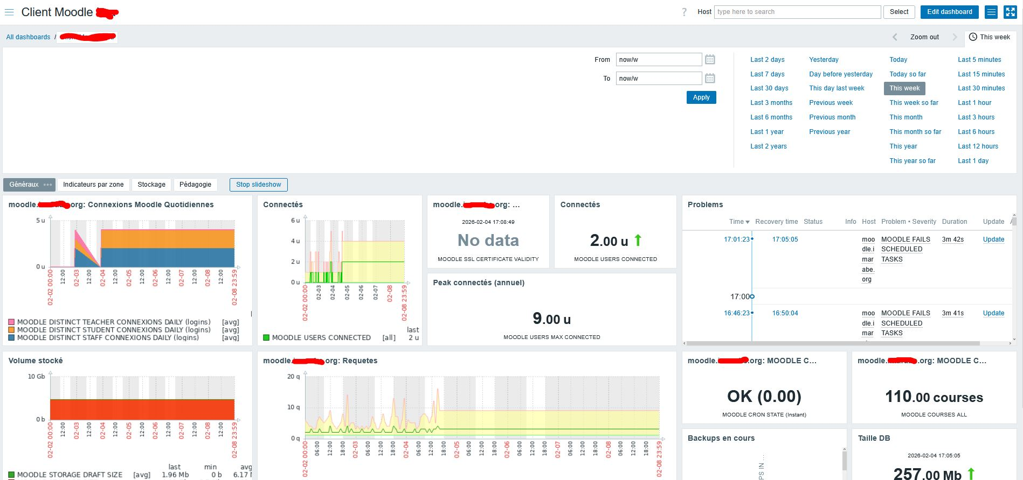 |  | 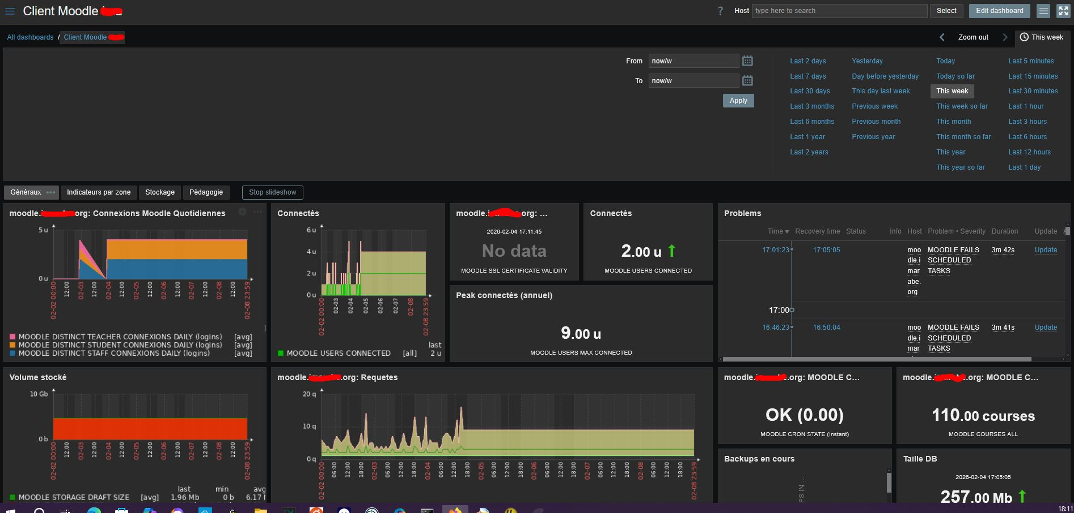
Sample screens : light and dark themes are possible

Guides
- Installation Guide
- User Guide
- Technical guide
- Guide for moodle plugins developers
- Screen samples (Zabbix dashboards)

Summary of features
- Instant indicators recollection (continuous measurement points)
- Hourly indicators recollection (continuous data or hourly cumulations)
- Daily indicators recollection (data accumulated over 24 hours)
- Weekly indicators recollection (data accumulated over 7 days)
- Monthly indicators RECOLLECTION (accumulative data over the past month)
- Measurement definition classes (how to develop your own additions)
- Auto installation in the Zabbix Server by API.
- GDPR Compliant : No registered “individual” personal data

PRO features
- Discovery of indicators in third-party plugins
- Automatic discovery of in-situ-related data (course categories, authentication plugins, courses requiring targeted collection, etc.) for segmented statistics
- Customized indicators (configurable by administrator)

Roadmap
- Global indicators on cohorts
- Discovery of cohort data
- Discovery of user data (individually calculated statistics, GDPR compliant)
- Return to Moodle of calculated indicators (“reserver_results block” and other forms of integration of results in the Moodle interface)

Prerequisites
Works with Zabbix > 6.4

General structure
The report plugin uses the zabbix_sender command to send measurements made in Moodle to Zabbix at an appropriate rate adapted to the data semantics and “variability”. All measurements are defined in “Zabbix Templates”, applicables to “hosts” representing a particular Moodle.

Information on measurements
Measurements and their documentation exploit concepts specific to industrial measurement context. See documentation on measurements design for more details.

Tasks for sending measurements
Five Moodle scheduled tasks, will perform the data emission to the Zabbix server. Emission tasks can also be operated through CLI scripts.

Templates
Templates are definitions of indicators that can imported in Zabbix as templates, and applied to hosts in the Zabbix.

Available templates for Moodle host
- MOODLE : General template (64 measures). List of measures
- MOODLE ADV PERFS: Specific template for advanced performance analysis. (12 measurements). List of measures (PRO)
- MOODLE ENT INSTALL : Template for performance analyses of the academic feeding (french model).
- MOODLE SHOP : Specific template for analysis of the built-in moodle shop.
- MOODLE LTC : Specific template for tracking professional developement courses.
- VMOODLE : Specific measures upon the Moodle virtualization plugin. List of measures
Roadmap :
- MOODLE PDCERTIFICATE: Specific template for getting stats on learnign certification issuance related to the Plugin for Professional Development Certificate].
- Optimize the massive scanning performances for custom measurements targetting non system contexts.

Template for Group of moodles
Moodle group templates do not receive data directly from Moodle instances. They define calculated elements consolidating the individual outcomes of participants in a host group that brings together a number of Moodle hosts.
- MOODLE GROUP : Template for consolidation in a multiple moodle installation (Teaching organisation scale, virtualized moodle grid) (18 measures) List of measures

Technical data sheet
- Component Type : Report
- Name : Zabbix
- Functional family : Administrative Tools
- Versions : to
- Availability : Stable

Credits
- 2022 Valéry Frémaux (valery@activeprolearn.com)
Return to plugin index -Return to catalog

