

User guide

Zabbix Report

Overall Presentation
The Zabbix report is report plugin performing measurements and data emission to a Zabbix Server and has no direct interface in Moodle. Only global configuration is necessary to ensure operation. The measurement results are exploited in the Zabbix interface, through graphs, recollection screens, or customized dashboards.
Path : Site admin ⇒ plugins ⇒ reports ⇒ zabbix sender

Report configuration
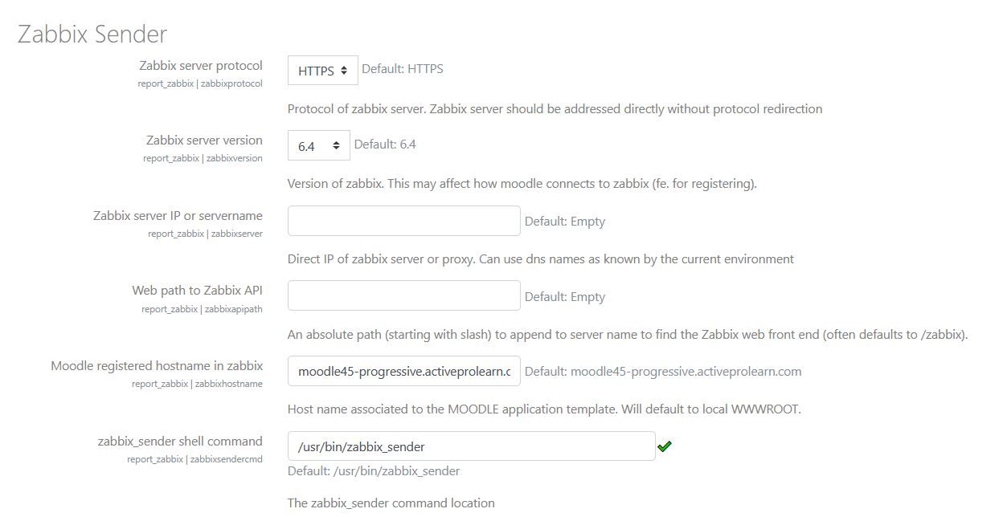
Zabbix server protocol zabbixprotocol: The server's protocol used for administration operations using the zabbix API. the Zabbix server should be directly accessible without redirects. Default : HTTPS
Zabbix server IP zabbixserver: direct IP of the server or zabbix proxy. A known DNS name is acceptable - Default: Empty
Moodle host name in zabbix zabbixhostname: The host name used to defined the host entry in the Zabbix server configuration. Herein name must match exactly what was used in host definition.
zabbix_sender shell commandzabbixsendercmd: The location of the “sender” command to send data to Zabbix. Defaults to: /usr/bin/zabbix_sender
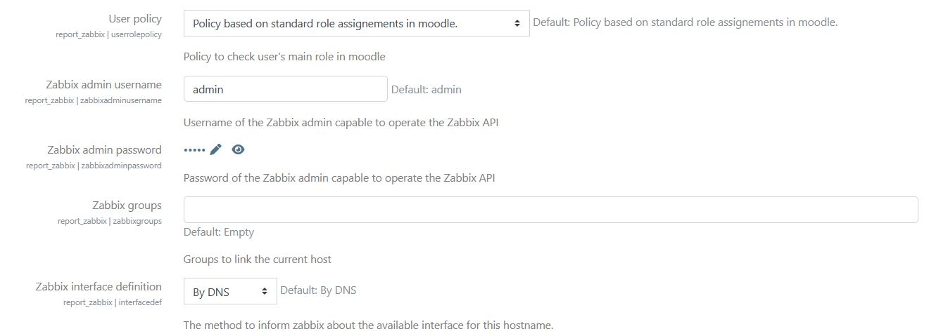
User roles userrolepolicy: Method for determination of user roles. This determination can be usefull for some values that are indexed to a user role, such as Studetns or Teachers, f.e. when counting connections. Some methods require special configurations. Default: Resolution based on standard role assignments of moodle.
- Other choice: Resolution based on profile fields (case of Moodle in ENTs)
Username Zabbix zabbixadminusername: The administrator's username who can operate the Zabbix API. This user must have been created in the Zabbix administration. This user does NOT need to access the Zabbix frontend. However, he do needs to read and write in the MOODLE models of the zabbix host associated with Moodle. Default: admin
Zabbix password zabbixadminpassword: The administrator's password allowed to operate the Zabbix API.
Zabbix groups zabbixgroups:
Groups (comma separated list) to attach this host to. Zabbix hosts representing a moodle can be grouped into zabbix groups to perform measurement consolidations using a MOODLE GROUP template. This template provides predefined aggregations on most common indicators.
Definition of the local interface interfacedef: A method to inform Zabbix server on which network interface it will communicate with this server. Default : By DNS
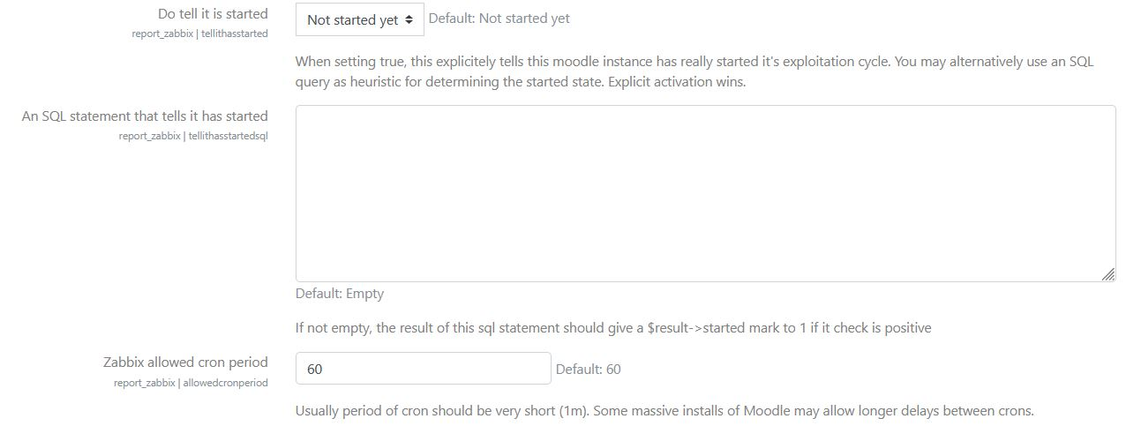
In operation tellithasstarted: By activating this box, you inform Zabbix that this platform is a production environment. This is usefull when grouping moodles in a Moodle Group in Zabbix, so that effective production plaforms can be identified (vs. candidate instances, or preproduction instances).
You can alternatively define a finer heuristic using a SQL query to determine this state. Explicit activation (this parameter) prevails. Default: Waiting for operation
SQL heuristic for exploitation tellithasstartedsql: An SQL query delivering a result named “started” determines the production state of the operation. Default: Empty
Zabbix allowed cron period: This was recently added for some installations of Moodle using large Moodle arrays (f.e. using Moodle Virtualization plugin). In that case, we would need to slower down a bit the Zabbix frequency specially for the instant task to lower the data recolection technical impact on the installation (we used it f.e. on large array with 350 moodles aside)
Registration in zabbix: By using this form, and pursuant your Zabbix administrator remote user is created and has sufficient permissions, you can ask the Zabbix server to register the local host definition that matches this Moodle.
Once the settings are properly setup, save them once. then, go to the registration process clocking on the link. You will be routed to a confirmation screen:
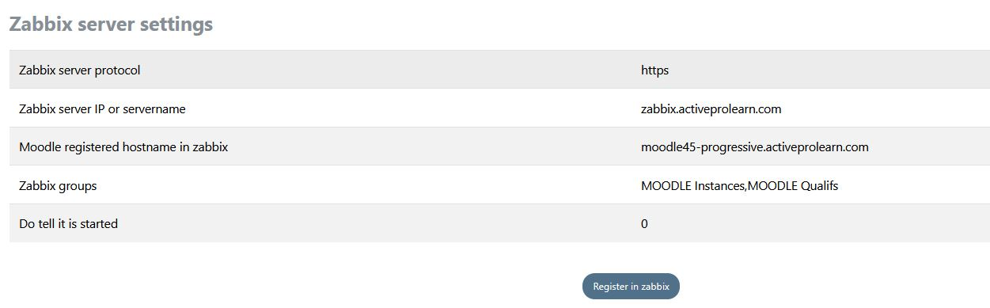
Clicking on the confirmation button will send all the required information to Zabbix to initiate a new host configuration for your Moodle. Of course the administrator user needs to be correctly setup in Zabbix for the registration to work.

PRO version
By entering activation keys obtained from your TMA provider, you will activate the plugin's additional features:
- Moodle Plugins local indicators (See our plugin developer guide for more details on how designing your specific indicators in your plugins).
- Zabbix discovery of Moodle dynamic environment (read the additional guide for setting up discovery)
- Moodle administrator defined custom measurements (without coding)

Back to Zabbix Report index - Back to plugin index - Back to catalog

