User guide : dynamic discovery

Zabbix Report
Dynamic discovery is a great feature of Zabbix that allows getting some metadata on element to discover in the monitored architecture, then apply some measurement prototypes to each of the discovered items. A usual examble of this feature is when discovering automatically storage disks on a server to monitor their size.
The Zabbix Report plugin has special URLs to let Zabbix make discovery of:
- Course categories
- Courses
- Authentication methods
At start, but the model is fully extensible to anything else that would need to be dynamically inspected.
Note that Discovery is part of the Pro version of the plugin and needs a valid License Key to be available.

Setting up the dynamic discovery
Dynamic discovery can be tuned in the Zabbix Report global settings, in order to focus to exploitable items and reduce the scanning range.
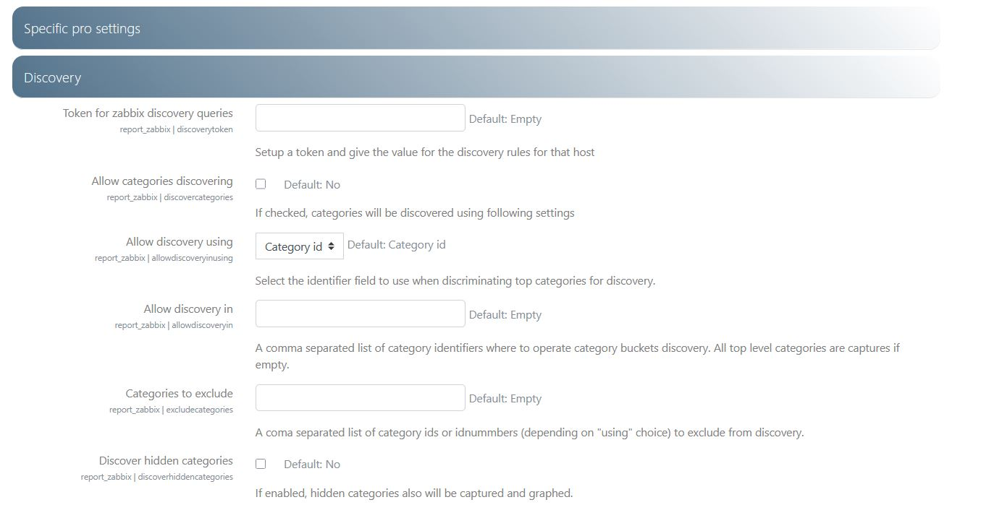
Token for zabbix discovery queries: First of all we need to secure the discovery process. Enter here a randomly generated token you will also report in Zabbix recovery parameters. This will ensure your moodle NOT TO BE scanned by other agents. A MD5 token is usually enough to secure the communication.
Token will have to be reported in discovery rules settings for each rule. Discovery rules are pre-installed when assigning the model to the zabbix host definition.
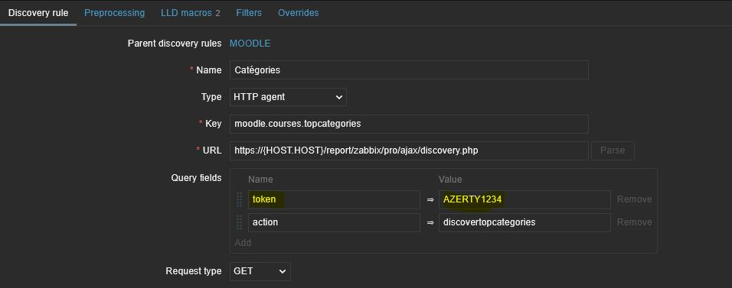
Related: Discovery Rules
Allow categories discovering: Check this checkbox to enable course category discovery.
Allow discovery using: You can choose to discover by ID or by IDNumber. Sometime, IDNumbers can make things easier when we need to identify a category. This parameter will have impact on both following settings:
Allow discovery in: A list od Ids (or IDNumbers) or parent root categories to discover. If empty, the top level categories will be discovered. Note that discovery IS NOT RECURSIVE, only direct children of the given ids will be retrieved.
Categories to exclude: a list of category ids (or IDNumbers) to exlude from the above result.
Discover hidden categories: Does what it tells…
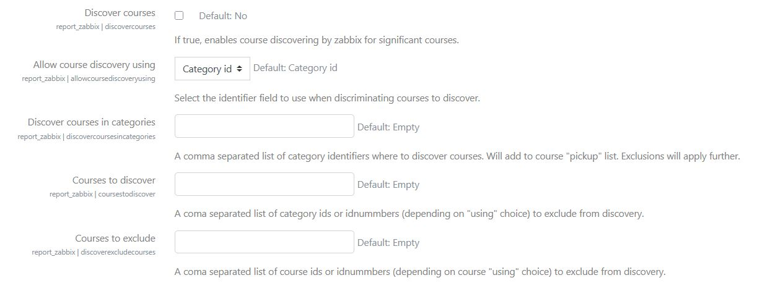
Allow course discovering: Check this checkbox to enable course discovery.

Back to Zabbix Report index - Back to plugin index - Back to catalog

