

Professional Development Certificate
- Component type: Activity module
- Name: PDCertificate
- Versions : to
- Distribution : Public and PRO
- Disponibilité : Stable.
- Repository: https://github.com/vfremaux/moodle-mod_pdcertificate
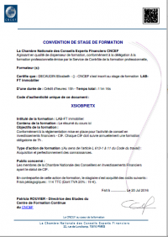
This module is a fork of the Community Certificate module, transformed to meet the following needs:
- This module allows a more powerful and flexible layout than the community plug-in “Certificate” offered by the Moodle community, allowing to customize each certificate in different ways, with layouts ranging from the formal letter to the diploma in landscape format.
- Course enrol chaining allowing to define“following courses” in which the user will be enrolled after certificate issue.
- Extra role assignment on tje certificed course, one of it's upper category or at site level upon certificate issuing.
- Delivery lock, neading a teacher to get the certificate for physical marking/signing by a local authority.
- Configurable Certification authority
- Delivery unlock can be triggered by an external event from an external plugin such as Moodle shop).

Guides
- Install Guide
- User guide
- Tecnhical guide

Builds
Travis-ci continuous integration
Note : Failing status is not necessarily the sign of a non functionning module. It just says that the moodle code standards check are not fullfilling. This is a continuous effort of us rewriting the plugin code to get it compliant.

Auteur
- Valery Fremaux (Developement)
- Florence Labord (Documentation)

Back to plugin list - Back to home

