

Flashcard Set Module
- Component type: Activity module
- Name: Flashcard (Cartes flash - Système de Leitner)
- Versions: to
- Old versions: 1.9, 2.2 to 2.6
- Distribution: Public and PRO
- Availability: Stable
- Repository: https://github.com/vfremaux/moodle-mod_flashcard
- Unit tests: https://travis-ci.org/vfremaux/moodle-mod_flashcard/branches
- Distributor: Activeprolearn SAS
Important : read our plugin support policy

Module summary
The flashcard plugin helps to memoizing things and helps reinforcing the long term memory. This plugin implements the Leitner method who discovered the effect of the information refresh reptition in the memorial reinforcement. The more you update an information, deeper is the engraming of the information into the neural network.
Leiner also discovered that in a set of things to learn and memorize, some items will resist to the engraming (some times not the apparently hardest). The leitner method uses both “repetition” and “focus to resistive items” to optimize the learner's learning time.
The plugin proposes to check regularily a set of associations presented as a card set. On each card is printed a question and the answer on the other side. Question and answer may be just texts, a pair of linked concepts, but card sides also can use media such as sound, image or video.
The flashcard activity will propose a challenging way to learn and memorize the associations.
When the game starts, cards are all placed in the first deck, which is known as being the harderst deck. Sudents are asked to check the different decks, from the hardest to the easiest. The learner will review the deck and trying to remind the answer. The learner self assesses his answer and will declare it has passed or not. When a card is passed, it migrates to the next easier deck. Of course, easier decks will be scheduled less frequently or revision, thus concentrating the effort and learning time on harder items.
The final goal of the activity is to migrate all cards in the last (easiest) deck.
To harden the exercice, you may activate an erosion feature that will migrate back cards upwards if they are NOT revised as required.
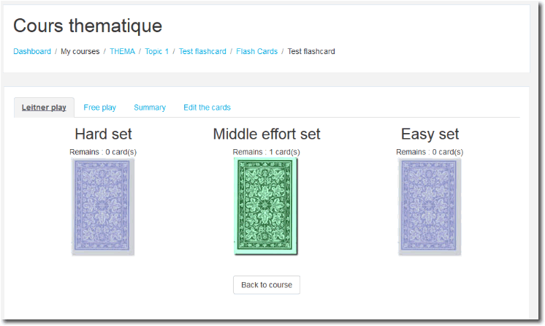

Guides
- Install Guide
- User Guide
- Technical Guide

Features
- Activity configuration and setup (teacher)
  - Media type on front side (text, sound, image, video)
  - Media type on rear side (text, sound, image, video)
- Creating cards (teacher)
  - Unit creation
  - Importing cards (text/text)
- Training (student)
  - Free play
  - Leitner play
- Stats and results (teacher)

Builds
Travis-ci Continuous integration
Note : Failing status is not necessarily the sign of a non functionning module. It just says that the moodle code standards check are not fullfilling. This is a continuous effort of us rewriting the plugin code to get it compliant.

Credits
- Gustav Delius
- Tomasz Muraz
- Valery Fremaux (valery@activeprolearn.com)

Plugins index - Back to catalogue

