

Course Element Subtype : Authoring note
The Authoring Note serves to coordinate course design work between all people having access to the editing mode of the course. Moreover, in an organization having a 2 course editing levels process (pedagogic design, course content authoring), it is common that course authors use preformed course templates. Template designers will use this element to give authors authoring instruction related to the template construction.
As for the Pedagogic advice, student and non editing teacher will not see this note in standard configuration

Render example in course
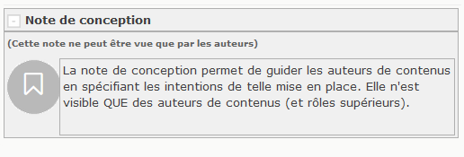

Element instance configuration

General settings (element specific)
- Choose “Authoring note” as the element type. (If the element had previous content, an alert will be triggered).
- A new element name is computed if it was empty.
- Enter the note content.
Visible at page load (option)
If enabled, the note will be expanded when course page loads. this may be usefull for very important notices that teachers must read before starting to exploit the course material.

Back to user and pedagogic guide- Return to the component index -Back to the general plugins index - Back to home

