

Professional Development Certificate
- Component type: Activity module
- Name: PDCertificate
- Technical Name: mod_pdcertificate
- Versions (maintained): to
- Distribution:
- Availability: Stable.
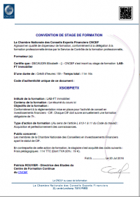
This module has been inspired from Community Certificate module, but now is hugely transformed to meet the following needs:
- This module allows now a powerful and flexible layout and content management, allowing to customize each certificate in different ways, with layouts ranging from the formal letter to the diploma in landscape format.
- Data injection of many environmental data (user profile, course, etc.)
- Configurable backgroud
- Configurable delivery mode

Extended Pro features (with active license key)
- Course enrol chaining allowing to define“following courses” in which the user will be enrolled after certificate issue.
- Multiple page layout
- Yet more data injection, from other plugins, grades, etc.
- Extra role assignment on tje certificed course, one of it's upper category or at site level upon certificate issuing.
- Delivery lock, neading a teacher to get the certificate for physical marking/signing by a local authority.
- Configurable Certification authority
- Delivery unlock can be triggered by an external event from an external plugin such as Moodle shop).

Guides
- Install Guide
- User guide
- Tecnhical guide

Builds
Branch | Check status
405
501
Note : Failing status is not necessarily the sign of a non functionning module. It just says that the moodle code standards check are not fullfilling. This is a continuous effort of us rewriting the plugin code to get it compliant.

Credits
- Valery Fremaux (Developement)
- Florence Labord (Documentation)

Back to plugin list - Back to home

