

Magtest multitrack test :Manage categories

Introduction
Multitrack test is based on output categories. Each output category is a scoring track by itself. When setting up a magest instance you first need to create at least 2 output categories. Categories will also provide some feedback to the user when a dominating score is calculated.
When students choose an answer for each question, the weight of the answer (defaulting to 1) is added to the category score the answer is associated to.
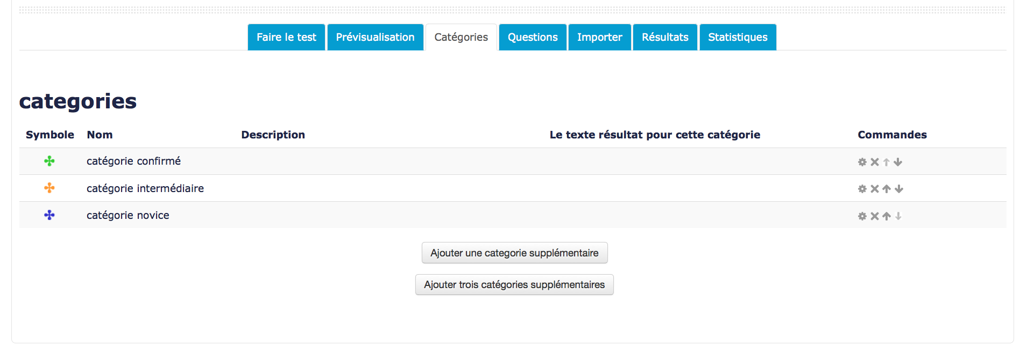
From the category list, you can add one or three categories per action.

Adding categories
- Click on the “Add a category” button
- Fill in the form
- Click on “Save”
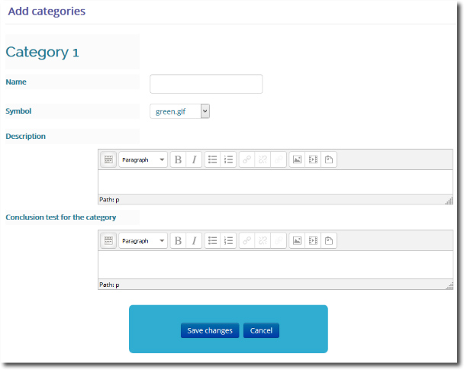

Deleting a category
Deleting a category will delete also all answers attached to this category in all registered questions. It will also delete all user scores linked to that category.

Back to component index - Return to the user guide summary - Plugins index - Back to catalogue

