

Multitrack test (Magtest)
- Plugin Type: Activity module
- Name: Magtest
- Versions: to
- Old versions: 1.9, 2.2 to 3.0
- Distribution: Public
- Availability: Stable
- Repository: http://github.com/vfremaux/moodle-mod_magtest
- Unit tests: http://travis-ci.org/vfremaux/moodle-mod_magtest/branches
- Distributor: Activeprolearn SAS (worldwide)
- CPDR Compatibility: Written
Important : read our plugin support policy
The Magtest activity module is named referring the historical presence of this kind of tests in press magazines. The master process of the test is to dispatch the participant into output categories using a set of multiple score questions, and provide a specific feedback for each category. the Magtest is simple configure and use.
What follows is the basic process of the magtest:
The teacher defines a set of output categories. A set of questions will be defined, and an answer proposed for each output category. The student answers by selecting the appropriate answer in the answer set for each question, with no explicit information about the output category associated to the answer. Each category tracks a score. The max score obtained in a category will determine the dominating category.
The teacher can choose if the test can be replayed. Teachers also can weight the answers so they contribute more or less to the category score.
Ex: Magtest teacher view
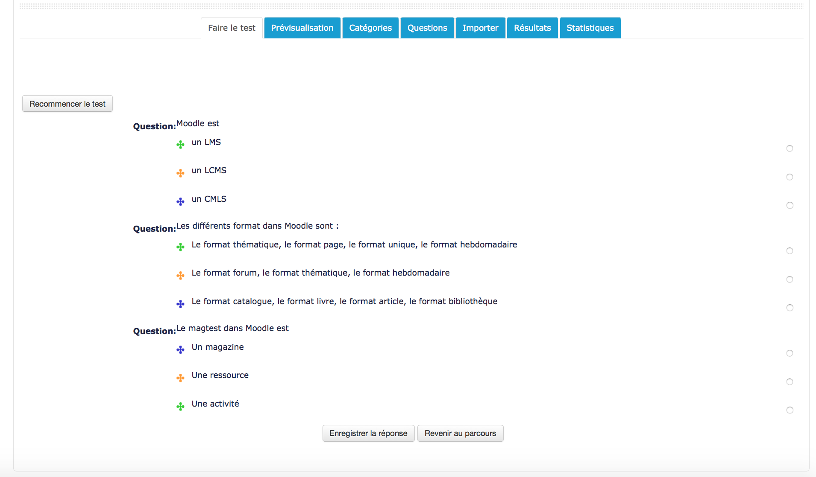

Binary answer mode
In binary answer mode, the student only can answer “yes” or “no” to the question. Answers text is not displayed to users, and all scores are added to the categories depending on their individual weight.

Features
- Test authoring
  - Category management
  - Question management
  - Importing questions
  - Multiple answer mode or binary answer mode
- test execution
  - Preview mode for teachers
  - Attempting the test
  - Watching results

Guides
- Installation guide
- User guide
- Technical guide

Credits
- Etienne Roze
- Valéry Frémaux (valery@activeprolearn.com)
Return to plugin index - Return to home

