

User guide

Course Elements

Introduction
General presentation of the course elements

Meta elements
Former two element are generaly used in top section or cover page of a course. Latter two elements are used to help coordination between course assessors or designers.
- Information about course
- Information about authors
- Pedagogic advice
- Authoring note

Structural Elements
Those elements structurates the visual organization of the course page content. they are essentially intended to render as titles. They are provided here in a usual hierarchical order, but we experienced sometime some alternate semantic ordering of the levels. This is not impacting the element concept in itself.
- Course heading
- Section header
- Sequence header
- Content unit header

Generic Elements
- Comment box
- Important !
- Simple text (2 reading levels)

Pedagogic elements
These elements are content pedagogic bricks and allow a nice unity of the course content with clear markers.
- Key points
- Work to do
- Definition
- Example
- Fundamental knowledge
- Information
- Method
- Local goals
- Question
- Remind
- Soluce
- Theorema
- Tips and tricks
- See also

Special elements
Those elements cannot fit into any of the preceding categories.
- Course Classifier
- Vertical column spacing (page format related)
- Contact point

Standard way of adding a course element into the course
- Switch the course in editing mode
- Click on an “Add an activity or resource” link
- Choose “Customlabel” in the resource choice list
- When entering in the configuration form for the resource instance, choose the element subtype in the first top setting, and let the form reload to presnet you the specific settings for this type.
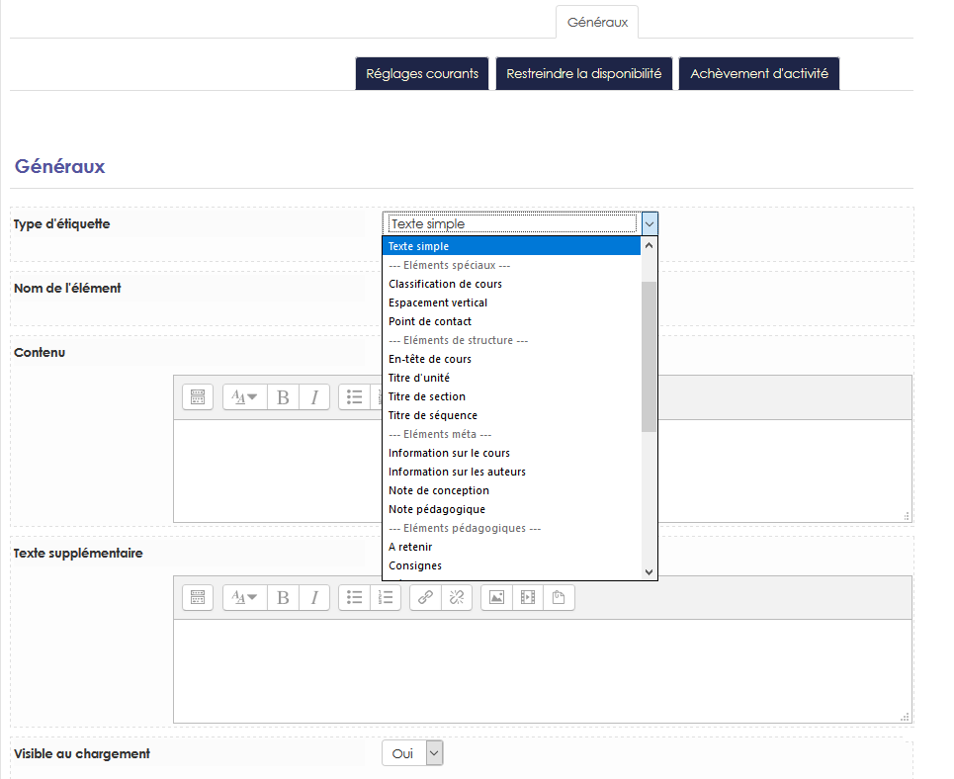

Configuring the plugin instance
- You will examine the specific settings for some course element subtypes, each one can have a distinct set of settings.

Return to the component index -Back to the general plugins index - Back to home

