

Course element subtype : Information about course

Introduction
the “Course Information ” subtype holds general meta-information about the course. The subtype allows you to choose the topics that are in use:
Goals:
Global pedagogic goals of the training material. Here can f.e mentioned that the course is provided to deliver a end of course certificate.
Acquisitions:
What knowledge, skill, behaviors will be acquire by learning in this course.
Concepts:
What are the key concepts presented and worked.
Pedagogic organisation:
How the course will be delivered and followed.
Prerequisites:
What prerequisistes do learners need to comfortably work in the course.
Following courses:
What course may learners apply to when they have achieved this course.

Element instance configuration

General settings (element specific)
- Choose “Course Information” as label subtype. (If element previously had content, an alert will appear).
- A new default name will be computed for the element if empty.
- Input the topics content text as relevant.

Other settings
The other settings sections are Moodle standard settings for all activities and resources.

Rendering example : SPOC course information
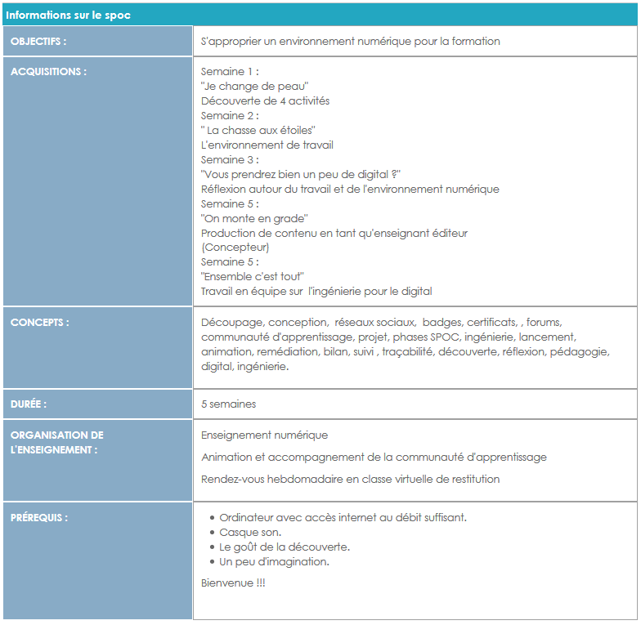

Back to user and pedagogic guide- Return to the component index -Back to the general plugins index - Back to home

