Install Guide

Tabbed and filtered QuickForms

Install the plugin
Two steps install:
- First install the plugin as usual as a local plugin:
  - Unzip archive into the /local directory of your moodle
  - Browse to the Site Administration / Notifications to finish the install.
- Then you need add the essential unique patch into the file lib/formslib.php. This will replace the standard form renderer.
You'll find patch and core reference into respectively the patch and reference metadirs of the plugin. Reference file is given to facilitate automatic patch detection and integration into automated assembling procedures. Check the patch marked by “ PATCH+” and “ PATCH-” and report into the corresponding location.
This change will affect ALL QuickForms in the whole Moodle. See next chapter to see how to exclude some local forms from the change.

Configure
Four settings need attention for configuring the TabbedQuickform plugin. Browse to:
Site Administration > Plugins > Local plugins > Tabbed quickforms
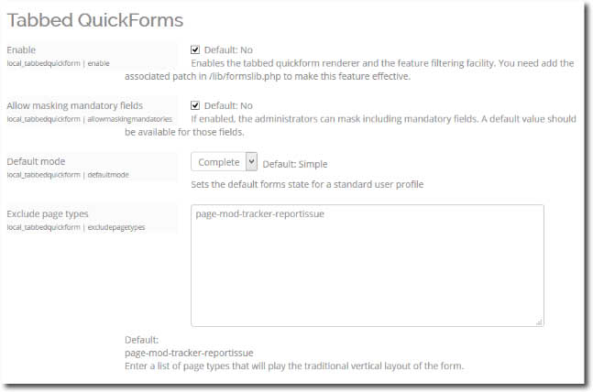

Enabling tabs renderer
By enabling the renderer, you will replace the standard collapsible sections with the new tabs renderer. This renderer also provides the global form filtering feature.

Enabling masking mandatory fields
This is NOT enabled by default, as this might have severe consequences on behaviour if admins mask fields inadequately, or recording inappropriate default values.

Default mode forms
As a default (apart any explicit choice in user's preferences), the initial presentation mode for forms can be:
- Filtered (simplified): Any masked field will not appear in the form.
- Complete: All usual moodle form fields are visible.
Users may be allowed to choose the form mode by themselves in their own profile.
Return to the plugin index

