

General condition of sales for a catalogue

Moodle Shop structure documentation

Structure information
Every sales initiative must specifically inform the customer of the seller’s commitment and the customer’s rights and obligations.
The Moodle shop can establish conditions of sale by aggregating the general conditions of sale attached to a shop instance, as well as conditions specific to each product purchased from the catalogue.
Conditions of sale are dynamically assembled when the order is taken and presented to the customer before the order confirmation stage. The user must tick a specific box to be able to preview their order and continue to the payment phase. Because the order is permanently recorded via payment screen inputs, the existence of a formal record of the order implies acceptance of the conditions of sale.
Moodle shop general conditions of sale interface:
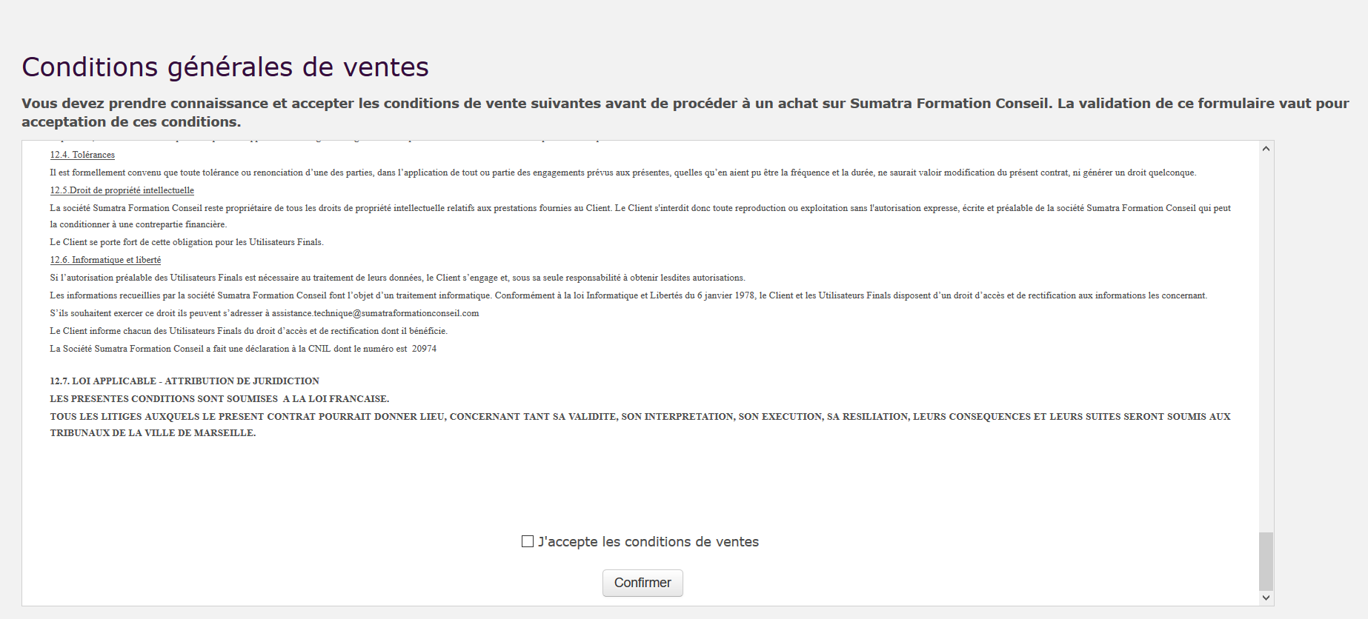

Back to the Moodle Shop structure summary - back to Local Shop componant - back tocatalogue

