

Customer class : Concept of customers accounts

Moodle Integrated Shop : Structural elements

Introduction
At a certain point, anyone who commits to the purchasing process (by submitting contact information) will automatically generate a customer account in the shop, which will store the information provided.

Customer account and Moodle user account
This customer account will be attached to a user account once a purchase has been completed.
When a purchase is launched in guest mode, on entry of customer contact information, authentication will also be proposed.
In the case of successful authentication, customer account data will automatically transfer to the customer information form. The customer can always modify this information if they so choose, in which case it will be rerecorded on their enrolment.

Customer support area
Once the user account is created, the customer can take advantage of certain services, such as access to an identified customer support area (a course specifically organised to provide customer support).
Customer support can provide a certain amount of services, customer account management accessories (generally via blocks), and private documentation, or other services established using Moodle’s standard or contributive features.

Example of customer account support area (course)
It can, for example, demonstrate access to customer bills and purchased products.
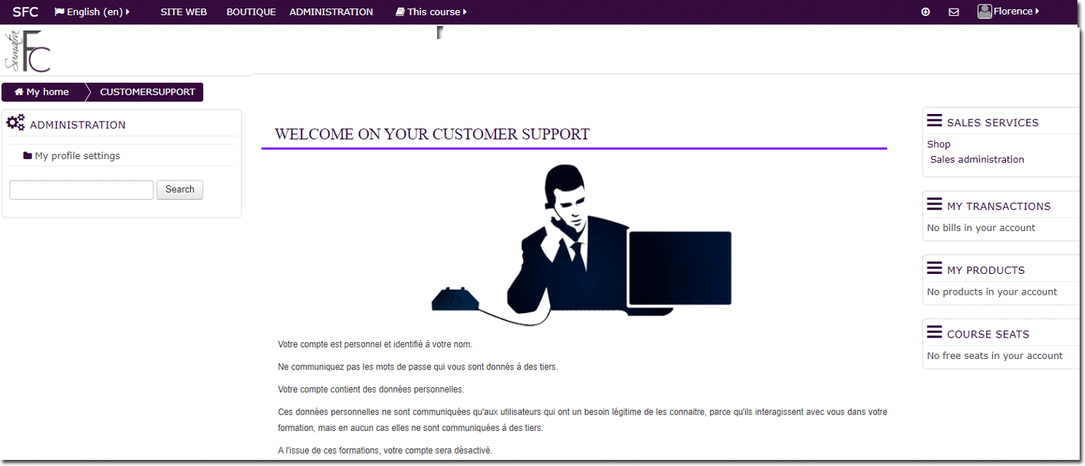

Attributs
to do

Back to the Moodle Shop structure documentation summary - Go to Configuration and implementation of a commercial offer - Back to Local Shop componant - Back to catalogue

