

Back Office : Configuration and implementation of a commercial offer

Define and manage taxes

Access using Sales department block
Link to “Sales administration” in the Sales department block (Shop Access plugin)
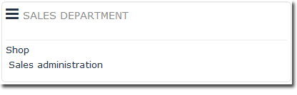
Then follow link “Manage taxes” on the Sales services page.
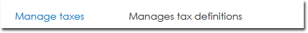
You must create taxes BEFORE you place products.
This is the menu from which you can create the taxes that will subsequently be available for the different products.
Add a tax by linking to “Add a tax”, then provide the following attributes:
- An available name for the tax
- A tax ratio
- The country where the tax applies (choose from dropdown list)
- The calculation formula using variables

Tax Ratio
This ratio is given as a percentage and can be a non-integer (e.g. 19.6 or 19,6 depending on the location)

Formula
This formula recognises the variables ht, and rt being the tax ratio.
In general, the typical formula for taxes is:
$ttc = $ht + ($ht * $tr / 100)

Tax exemption
You can define a special tax when certain special conditions lead to a one-off or sectoral exemption (e.g. exempt training initiatives vs. sale of educational materials subject to 10% VAT)
You would choose, for example, the following definition:
- Name: VAT Exempted
- Tax ratio: 0
- Formula: ht

Edit tax
- To edit an existing tax, click the gear icon at the end of the corresponding tax line.
- To delete an existing tax, click the cross at the end of the corresponding tax line.
Note : The shop does not allow you to delete a tax already associated with products.
Once your products have been created, the number of products attached to a given tax will appear in the “Number of products” column.
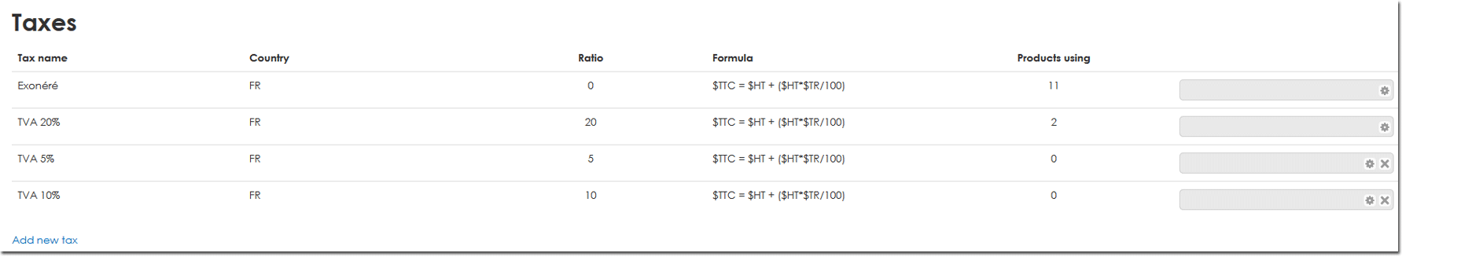

Back to configuration and implementation of a commercial offer - back to component Local Shop - Back to catalogue

