

Back Office : Configuration and implementation of a commercial offer

Define shop instance
(or verify your shop instance)

Access using Sales department block
Begin by adding the Sales department services block in a course that is used as “customer support” or a course of your choice on Moodle platform.
Site Administration/Add a Block/Sales department ( Shop Access plugin)
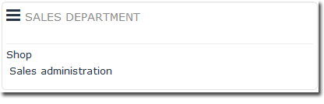
Link to “Sales administration” in Sales department block (component Shop Access)
Then, link to “All shops” on Sales Services block.
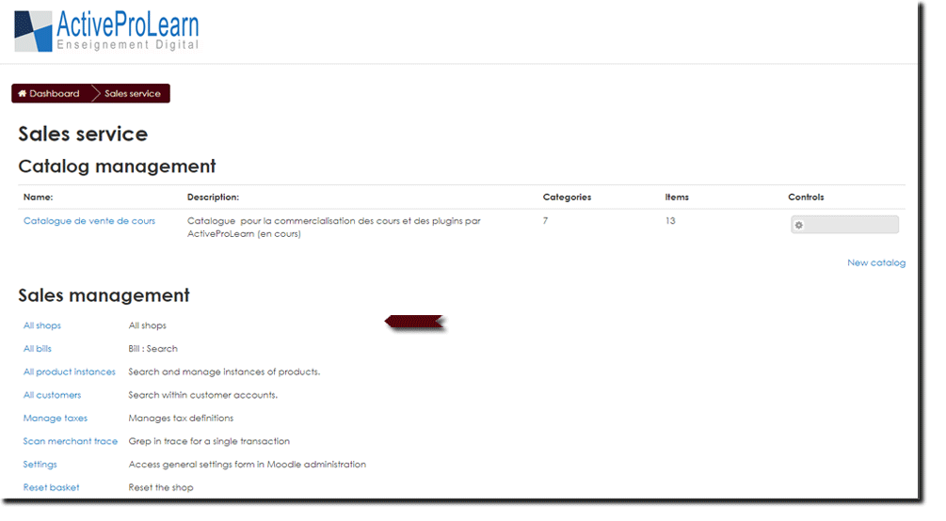
This menu allows you to create another shop instance or change the default one, with its catalogue and see how many blocks are attached to each instance.
Finally, click the “New shop instance” link at the bottom of the table displaying the shop.
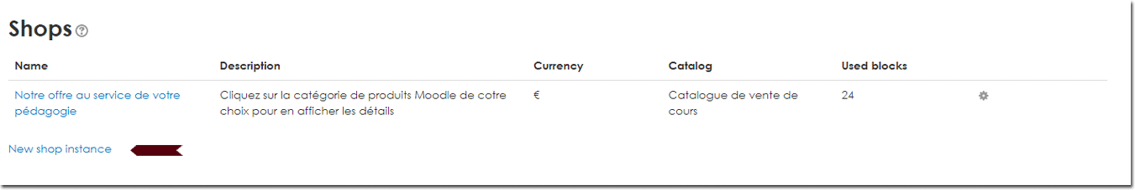{{ :bloc-shop-boutiques.jpg?nolink&400 |
- To modify an existing shop, click the gear icon at the end of the line of the shop created.
- To delete an existing store, click the cross at the end of the shop's line.
Note: You will need to to set the Sales department block(Shop Access componant) to have it point it to the desired store instance if you are running multiple shops.

Back to Configuration and implementation of a commercial offer -Revenir au sommaire du composant Local Shop (Boutique) - Back to catalogue

