

Back Office : Configuration and implementation of a commercial offer

Establish a product catalogue

Introduction
A catalogue will contain a complete collection of products. These products can be individual products, bundles, or sets

Access using Sales department block
Link to “Sales administration” in Sales department block (Shop Access plugin)
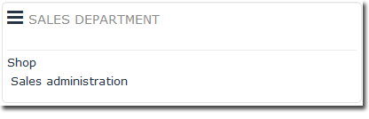

Create the catalogue
On the landing page, click the new catalogue link and provide the information requested:
- Name: Available name mandatory.
- Description: General description of the catalogue.
- General conditions: General conditions of remote sales linked to the catalogue.
- Standalone or master catalogue. (To learn more, define slave catalogues, link catalogues)
- Country of distribution.

On-screen display of the catalogue
Once your catalogue is created, it will appear in the list of product catalogues, as shown in this illustration, with the number of products recorded in the catalogue at a later time.
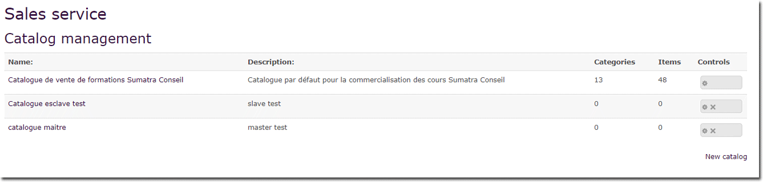

Settings and modification
- Name : catalogue name
- Description : catalogue description text
- Sales conditions : Sales conditions text for all catalogue products
- Country codes list : You can restrict the country choice list by giving the list of official country codes to use.
- Bill footer : Text that will appear in each bill footer
- Choose catalogue status :
  - Standalone catalog : default status
  - Master catalog : if it has to be a master with slave (s)
  - Linked to : choose a master calalogue to link to in the scrolling area
The created catalogue(s) can be modified via settings by clicking the gear icon to the right of the catalogue.
This is especially where you place the catalogue’s general conditions of distance sale, which must be accepted by customers to continue with their purchase.
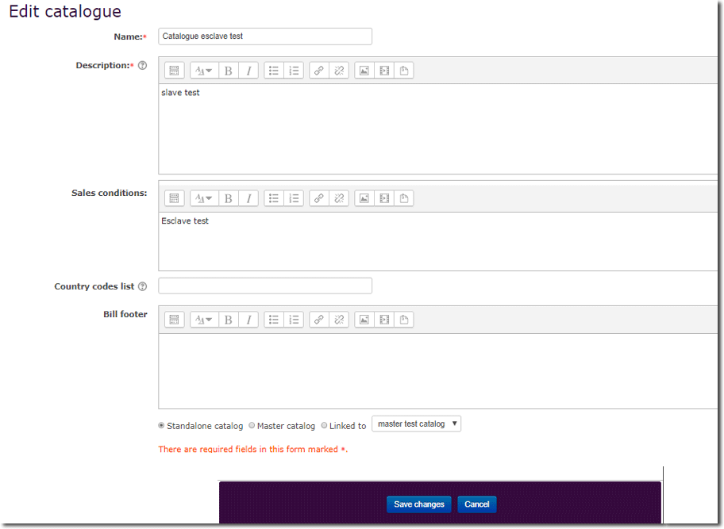

Back to Configuration and implementation of a commercial offer - Back to component Local Shop (Boutique) - Back to catalog

