

The Catalogue Class : Concept of catalogue

Moodle Integrated Shop : Structural elements

Introduction
the Shop catalogue is a container for managing products, sets, and bundles arranged into categories.
Several instances can be used in a master/slave configuration to override certain product definitions when necessary, e.g. for loading different languages in distinct countries, or changing public prices for certain shipping areas.

Catalogue typology
A catalog can be :
- standalone (default).
- master, by means it will accept slaves.
- slave, attached to a master catalogue, and used to locally override product information.
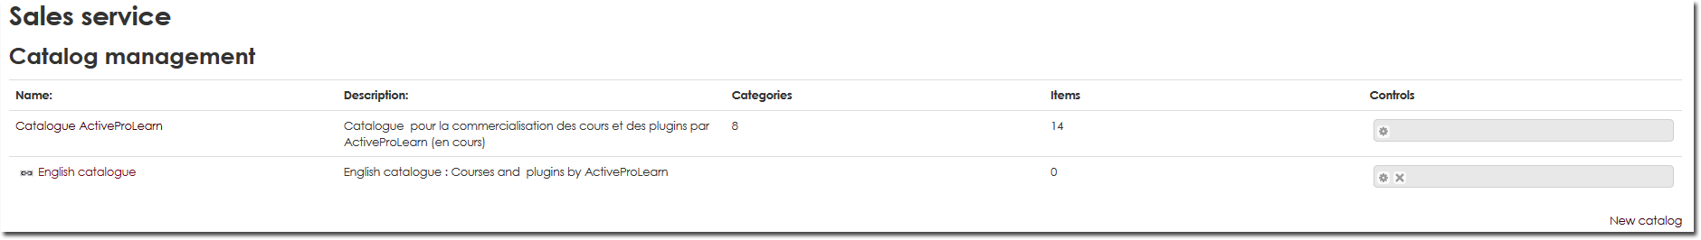

Standalone catalogue
This is the most common type, for simple sales in a single country/territory.

Master catalogue
The master catalogue holds the primary category and product definitions. This master definition will pre-set all slaves attached to it.

Slave catalogue
A slave catalogue will be used to override some product definitions of the master catalogue. There will be no provision to create new products, within it, just to redefine some external aspects of the original copy in the master. Product identity and technical settings will remain identical. Only front office and sales attributes, such as price, attached documents, descriptions, etc. can be overriden.
A shop can be assigned to a slave catalog. In that case, the shop will present the master products, overriden by 'in the way' slave definitions.
Deleting a slave catalog will NOT affect the master catalog. Deleting a product in a master catalog however will remove slave overrides attached to it.

Modify Catalog (Properties)
- Name : Internal (back-office) catalogue name.
- Description : Internal (back-office) catalogue description.
- Sales conditions : The general conditions of sales for the catalogue will be presented first and appended with product-specific sales conditions.
- Country code list : You can restrict the country selection list by providing the list of official country codes to use. Each country code must be separated by a comma.
- Bill footer : Your choice of text for the footer of each bill in the catalogue.
- Choose catalogue status :
- Standalone catalogue : default status.
- Master catalog : if it must be a master with slave(s).
- Linked to : choose a master calalogue to link to from the drop-down list.
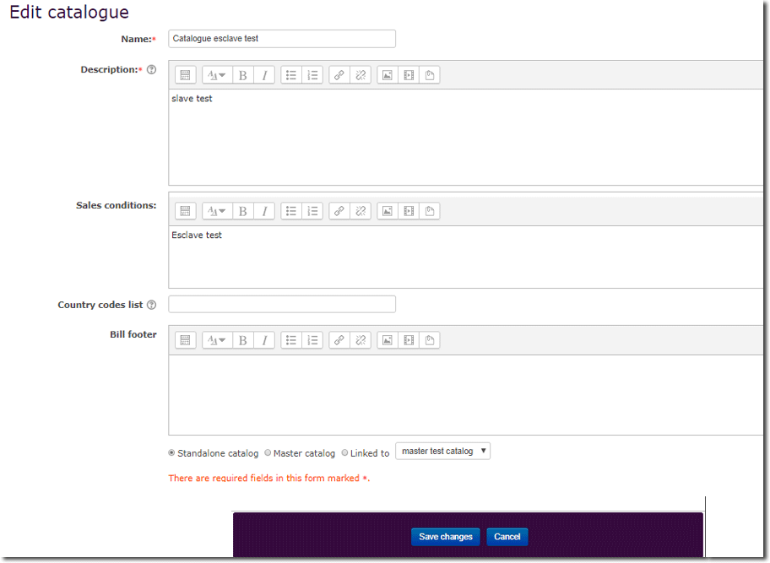

Back to the Moodle Shop structure documentation summary - Go to Configuration and implementation of a commercial offer - Back to Local Shop componant - Back to catalogue

