APL Core: Configuring additional user documentation for APL plugins
Some ActiveProLearn plugins provide access to an enriched documentation provided in addition to TMA support. The following parameters allows configuring access to this documentation.
Access to the extended documentation requires:
- A subscriber identifier provided by APL in addition to your products
- A public key provided by APL and corresponding to your subscriber ID
- Adequate documentation routing for APL plugins assumes an addition of code (patch) in the standard moodle code. If this patch is not present, the “standard” documentation of Moodle will still be accessible through the contextual documentation link.
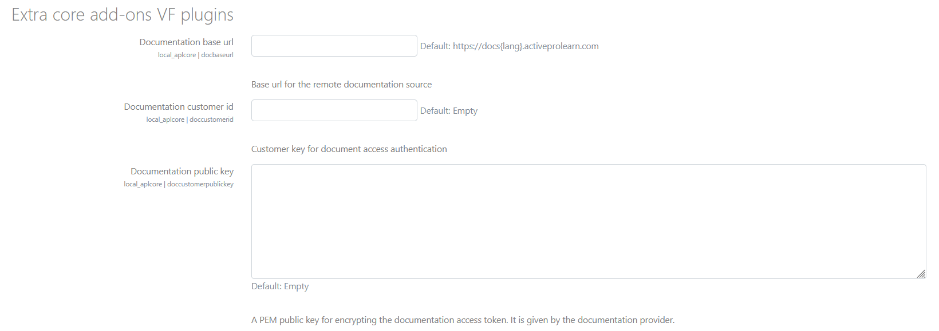

Documentation base URL
The URL of the Editor's Additional Documentation Service (APL). This URL may have a {lang} parameter to adapt the routing to a supported language of the documentation (currently only fr or in)

Subscriber id to documentation
Access to the extended documentation requires having obtained a subscriber identifier to the documentation. This identifier is provided to you by ActiveProLearn, in addition to your Application Third Party Maintenance licenses. Public key of documentation
The public key is provided by ActiveProLearn and allows to authenticate access to the documentation.

Plugin catalog for documentation
The list of plugins with extensive documentation can be updated when new plugin publications will arise. This setting allows you to add new plugins supported by the extended documentation, even after first installation of APLCore libraries.
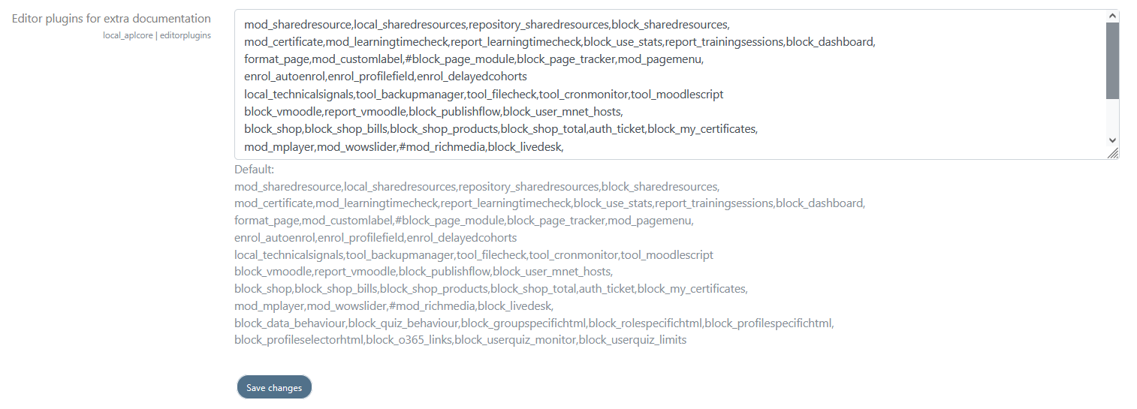
Back to plugin summary - Back to plugins catalog

