Reorganize pages

Course page format
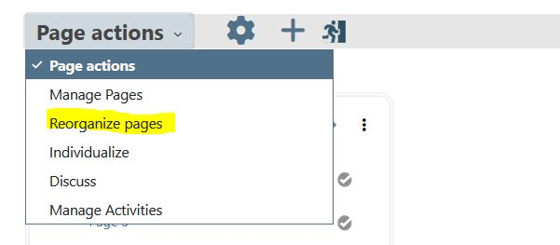
When in editing mode, click on Reorganize pages to get a page tree management screen
Administrators can globally choose between JS Tree and Flat reorganisation modes.
- JS Tree : Using a Drag and Drop library, may be a bit confusing, specially when trying to reorganize the top level.
- Flat tree management: Less confusing, but needs much more actions do rearrange things.

JS Tree arrangement method


Flat Tree arrangement method


Why not getting a nicer way ?
At the moment, all “clever” JS library to deal with tree dynamic arrangement that work effectively “well” are non GPL and often Commercial Licenced. We will check in future roadmap better candidates for this feature.

Credits
- Valéry Frémaux on an original development of MoodleRooms: Development and documentation
- Florence Labord : Documentation and illustrations
Back to user guide index - Back to Page format index - Back to plugin index - Back to catalog's home

