Manage pages

Course page format

Global page management view
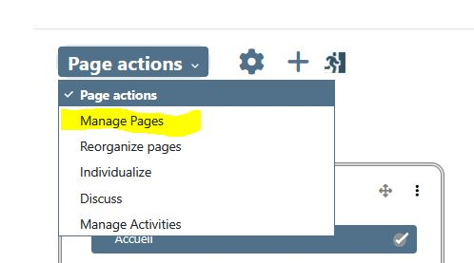
- Turn the course in Edit mode
- Find the “Manage page” entry in Page Actions dropdown
- Go to the page management screen

Quick edit of page settings
On course page, in editing mode, you'll find a direct access to page settings as a cog icon.
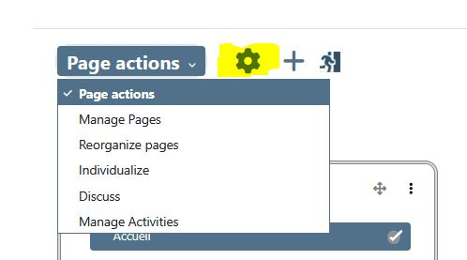

Page controls
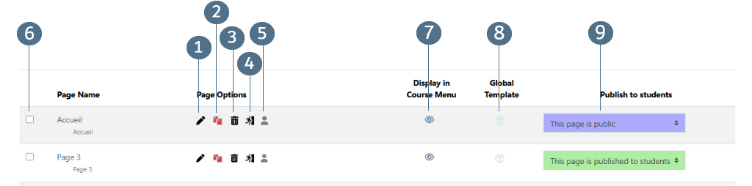

Page commands
- Edit the page clicking on pencil icon (1)
- Full clone the page clicking on copy icon (2). Full clone will duplicate and create new instances of course modules.
- Delete the page (3).
- Access to the page availability rules (4) (page availability rules relies on standard section rules).
- Assign pages individually to users (5).

Page selection
- Checking pages, you can make a selection of pages for a group command.
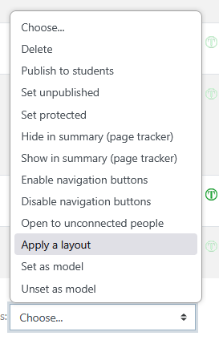
This is a quick way to change some key settings for a large set of pages.

displaying in menu
- Click on “eye” icon (7) to view or hide the page in the Course Summary block

Setting as global template
- Click (8) to turn the page into a reusable page template to create another one based on this template

Audience of the page (9)

- Public page : Visible for all in offline mode. Particularly useful for exhibiting the curriculum of the course and communicating.
- This page is published (to participants): Page with standard rights and abilities (Students consult, professor editors publish, teacher non-editors tutor etc.)
- This page is not published: hidden page for students, standard rights and abilities for others (editing teacher publishers, non-publisher teacher tutor etc.) Locked by capacity format/page:viewhiddenpages.
- Page protected : Page protected in editing, but visible to all in connected mode. (Locked by capacity format/page:editprotectedpages.)
- Page visible to authors of protected pages) : This page is completely hidden. Will only be visible on granted capacity: format/page:editprotectedpages So in general admins

Credits
- Valéry Frémaux on an original development of MoodleRooms: Development and documentation
- Florence Labord : Documentation and illustrations
Back to user guide index - Back to Page format index - Back to plugin index - Back to catalog's home

