Create a course in page format : User Guide
- When creating a course (any standard way)
- Fill in the requested items (name etc)
- In the course format box, choose “Page format”
- Save
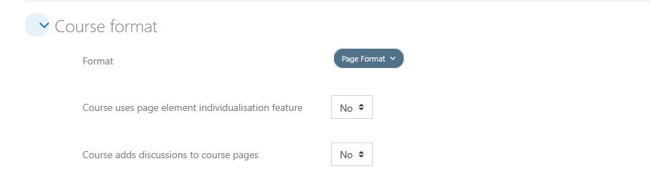

course format specific options
- Enable individualization: Individualization is a strong feature dedicated to give “per user”, additional or specific content. It is only available in Pro versions.
- Enable discussion side-pages: This is a special feature inspired by WikiPedia process, and sets up a side-discussion page when a course is designed (or operated) by a team.
See Page discussions.

Credits
- Valéry Frémaux on an original development of MoodleRooms: Development and documentation
- Florence Labord : Documentation and illustrations
Back to user guide index - Back to Page format index - Return to plugin index - Return to catalog

