Commenting pages (Pro)

course page format
Note1: Commenting page will require a global activation in the Page Format global settings by an administrator. Note2: Commenting pages is a pro feature that needs an active License Key.
Commenting page is a good way to coordinate efforts between remote course designers. The side discussion page is only accessible to editing teachers.
If page dicussions are enabled, the corresponding entry will appear in the Page action menu:
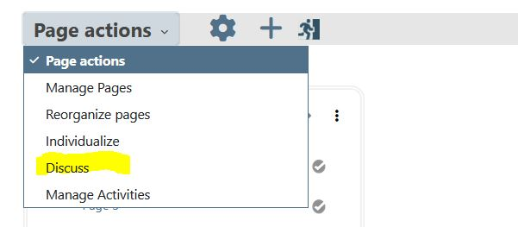
When clicking on the Discuss link, you will reach the discussion page, which is empty at start;
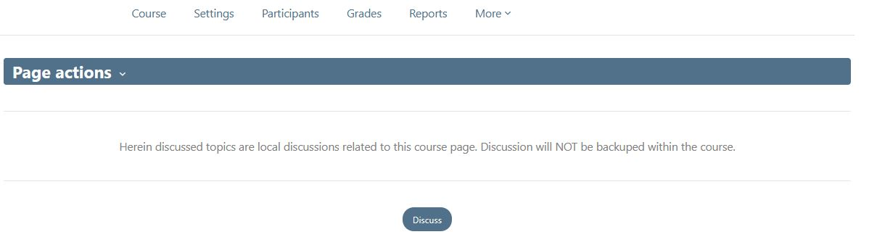
Click on the discuss button to access the discussion form:
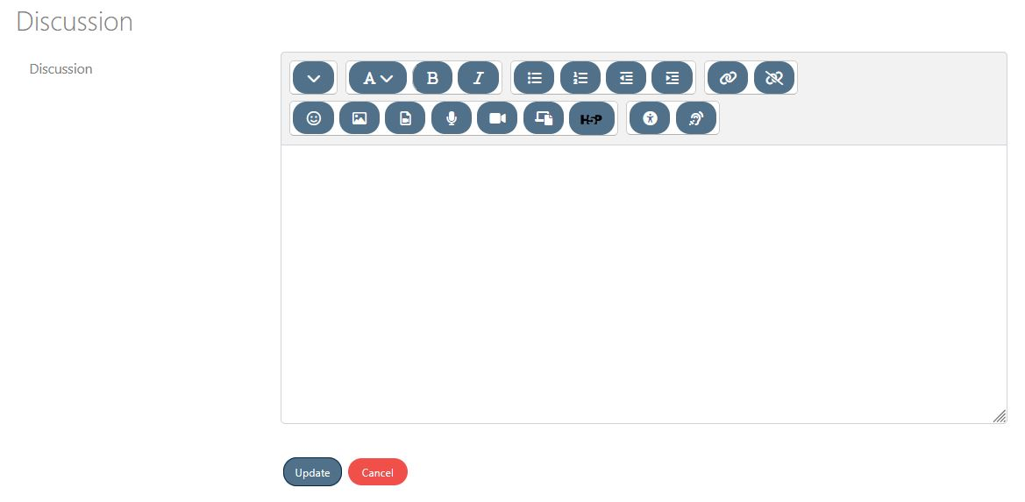
enter some text and update, the discusison will keep track of the group's messages
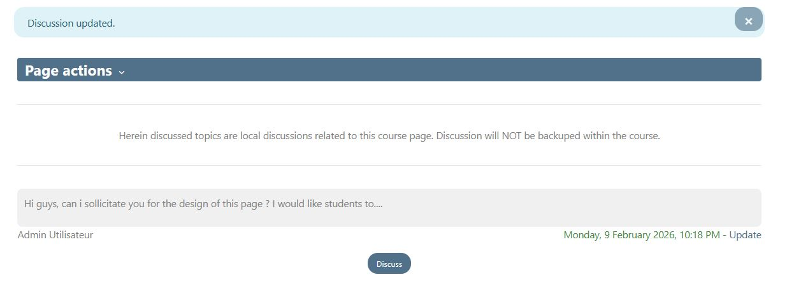
Note that you may update your message clicking on the Update link.
Keep in mind that this is a very simple accessory, and hos no complex message managing features as a moodle forum. Discussions will NOT be saved in the course backup.

Crédits
- Valery Fremaux dev@activeprolearn.com : Design and coding
- Florence Labord florence@activeprolearn.com : Documentation & illustrations
Back to User Guide index - Back to the course page format index - Back to catalog's home

