Administrator Guide

Format page

Global settings
Path : Site administration ⇒ plugins ⇒ course formats ⇒ page format
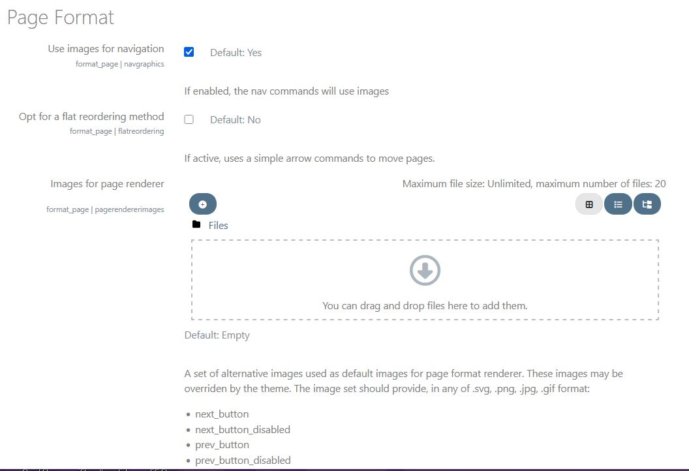
- Browsing images (navgraphics): Enable or not alternative images. Simple arrows by default.
- Opt for a flat reordering method (flatreordering): Enable or not flat reordering rather that JS tree manipulation library.
- Alternative images for the page format (pagerendererimages): Some images must care respecting expected names (see list), essentially to customaze the previous/next buttons. Png or JPG expected.
  - next_button
  - next_button_disabled
  - prev_button
  - prev_button_disabled
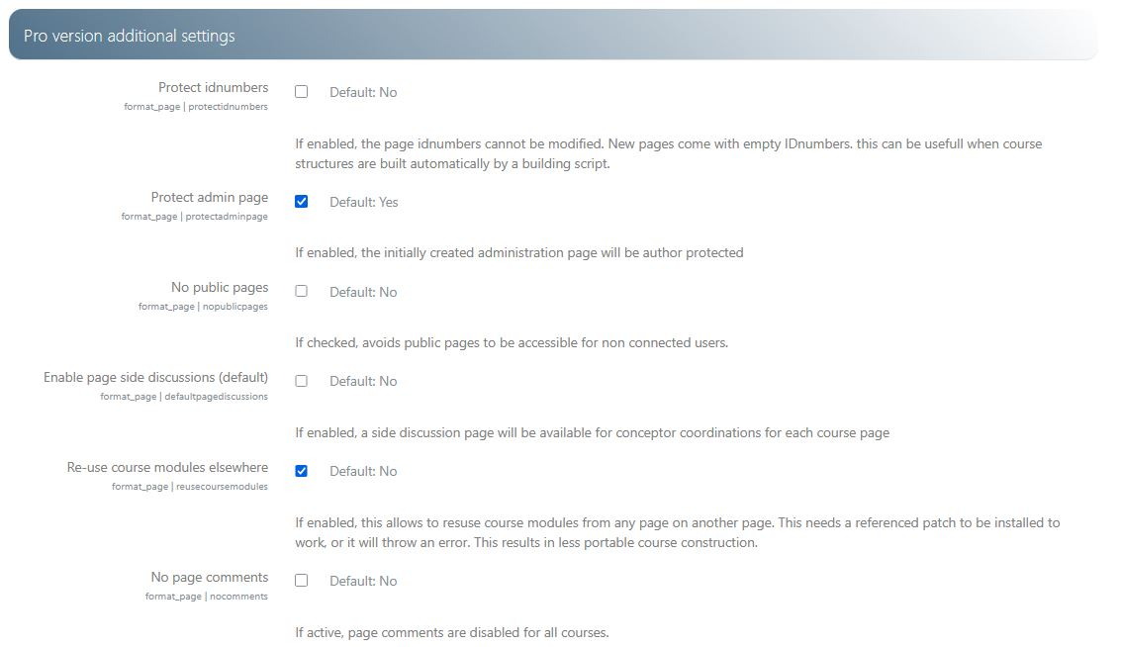
Note: The following settings need an active License Key from a distributor to be available.
- Protecting identification (protectidnumbers): If enabled, page idNumbers are non-modifiable. New pages have a non-filled/empty idNumbers. Tis is essentially useful in case of automated course structure creation.
- Protecting the administration (protectadminpage): If checked, the initial administration page will be created in “protected” mode, forbidding teachers (including editing) to alter it.
- No public pages (nopublicpages) :If checked, prohibits unconnected access to public pages. Public pages are readable only by authenticated users (including guest user).
- Enable page discussions (default) (enablepagediscussions): Tells the default state of page discussions for any new course.
- Re-use course modules elsewhere (reusecoursemodules): If checked, re-using activites and resources on other pages than the original page is possible. Format page core patchs MUST BE installed for this feature to work. Specially the patch in /course/lib.php disabling the course consistency check.
- No page comments (nocomments): If checked, discussion pages are off for the whole site.

Credits
- Valéry Frémaux on an original development of MoodleRooms: Development and documentation
- Florence Labord : Documentation and illustrations
Back to user guide index - Back to Page format index - Return to plugin index - Return to catalog

