

Block Use_Stats / User time stats : User guide

Adding a block instance
The Use Stats block can be added in any page context in moodle, pursuant the addinstance capability is owned by the current user.
Just turn the curent page environement in edit mode, and use the 'Add block' menu. Choose the “Use Stats” entry to add an instance to the page.
Only one single instance can be aded.
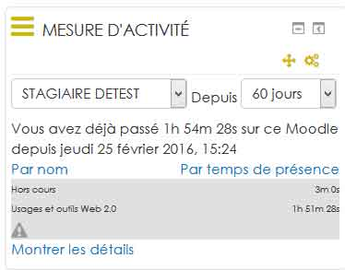

In block accessible controls
- User list (enabled people)
- From When (Sliding window exploration)

Data access modes (exploration modes)
- Student mode : For students, or for not specially enable users, only your own statistics will be displayed.
- Admin mode : In administrator (or specially enabled mode), you will be able to check the stats of any user present in the current environement.
- Shifting time window : the use stats gives statistics over a gliding windows ending at 23h59 local time of the current day, and starting some day count before the current date. The larger is the window, the higher is the performance impact on the server.

General Settings (Site wide configuration)

Some information on the block settings in central administration
All info in the technical documentation

Since block_use_stats | fromwhen
Compilation period Possible values: 5, 15, 30, 60, 90, 180, 365 Warning if value entered in free entry field not listed, this will take into account 5 days, ie the default value.

Filter times below (formerly session)
block_use_stats | filterdisplayunder Value in second of the time below which the time is taken into account but not displayed in the usestat block: If a session lasts less than one minute (60 seconds), it is considered as not significant, and it does not appear not in the block.

Reference time to display
block_use_stats | displayactivitytimeonly The block displays either the time spent in activities or the time spent in the History Analyzer Settings class.

Threshold
Credit time assigned by default to the work session in case of accidental termination of session. (Or without going through the menu “Disconnect”)
Example: Set to 60 min: If a learner has a period of inactivity in a session longer than 60 min, ie 1h, it is considered disconnected.

Overtime credit on the last ping
ping block_use_stats | lastpingcredit Additional credit time in minutes in case of no formal logout trace 15mn is the default

Show "outside course" times
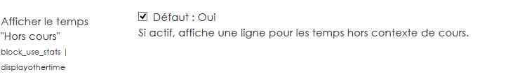
block_use_stats | displayothertime : Uncheck the box to hide on the interface of the block, the time spent outside the course (in the other spaces on the platform)

Reference time to display
block_use_stats | displayactivitytimeonly We display in the block either the time spent in the activities, or the time spent in the course (as for example on his personal file space, in forums, etc.).
One session per course
block_use_stats | onesessionpercourse If the check mark is enabled, then the parser will start a new session each time the trace changes course. Otherwise, a session may represent a work session that overlaps with several courses. (this setting is activated on our demo moodle platform)

Other useful elements

To change the label "Other class time" :
Go to the language files / block / settings.php configdisplayother time.

To hide the batch tab of the training session to teachers :
batch reports: remove the ability to the role to hide batch tab to the teacher role.

Check role permissions :
Course Admin / users / permissions / filter on report / trainingsessions: batch
But going through platform roles at the system level is better not to generate a local override of the rights on the relevant course.

To hide "show details" from the UseStats block to a learner:
block / use_stats: seeowndetails
set up to “undefined”

Additional information
- block algorithm Use Stats

Back to home - Back to plugin list order by type - Back to the component index - User guide - Technical index

