

Block Use_Stats / User time stats
- Component type: Block
- Name: Use Stats
- Versions: to
- Older versions: 1.9, 2.2 à 2.6
- Distribution: Dual release - public and PRO
- Availability: Stable
- Repository: https://github.com/vfremaux/moodle-block_use_stats
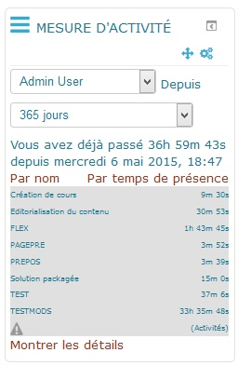
This block provides a central primitive to extract user time tracks from Moodle log. At start, the block was intended to provide users with a rough indication on how much they had spend on courses, and merely for teachers that might have to justify their online time to the learning staff. the road map extended the behaviour of the block to let people auditing learners time spent, and provide a calculation bases for more structured and formatted reports Training Session Report.

Guides
- Install Guide
- User Guide
- Technical Guide

Features
- Time compilation
  - Continuous user track timegaps compilation
  - Implicit session breaks management
  - Tunable 'last record' time bonus on session break
- Cubing (PRO version)
  - Optional compilation of qualified tagging on the logs from 6 parametric queries.
- Display
  - Individual display
  - Display of other users if authorized to
  - Detailed printing of time aggregation
  - Sliding period filter
  - Parametric fixed period filter
- Performance
  - Aggregate cache
- Export (PRO Version)
  - Exporting the time table to PDF (with Training Session Report)

Road Map
- Saving performance adding a pre-aggregation engine to speed up access to results on large usages.

Builds
Travis-ci Continuous integration
Note : Failing status is not necessarily the sign of a non functioning module. It just says that the Moodle code standards check are not full filling. This is a continuous effort of us rewriting the plugin code to get it compliant.

Credits
- 2006 Valery Frémaux (valery@activeprolearn.com)

Component origin
ActiveProLearn/Mylearning Factory component catalog.

Back to home - Back to plugin list order by type

