

ShopTotal Block (Front Office Order Total)

Moodle Integrated Online Store
- Component Type: Block
- Name: Shop Total
- Versions: 2.7 à
- Distribution : Part of the Moodle Integrated Store subset
- Availability: Release Candidate (RC)
- Repository: https://github.com/vfremaux/moodle-block_shop_total
- Unit test: https://travis-ci.org/vfremaux/moodle-block_shop_total

Description
This block is a complement block to the front-office screens. It has to be added by editing the front office landing page to implement the order totalizer.
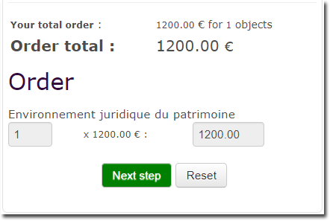

Guides
- Install guide
- User guide
- Technical guide

Features
- Total order display
- Order detail display
- Order reset

Related components
- My transactions (block Shopbills)
- Sales services (block Shopaccess)
- My products (block Shopproducts)
- Course seat assignation (block Courseseat)

Other external Components linked
- Ticket based authentication (authticket)
- User Quiz Limit Block

Builds
2.7 | 2.8 | 2.9 | 3.0 | 3.1 | 3.2
Travis-ci Continuous Integration
Note : “Failing” state will NOT stand necessarilty for the plugin is NOT functionning. this status essentially gives the state of the Moodle Coding standard testing suite, and will denote how close to moodle code requirements the plugin is.

Credits
- 2014 Valery Fremaux (valery.fremaux@gmail.com) - Conception, codage
- 2016 Florence Labord (info@expertweb.fr) - Mise au point, revue fonctionnelle
Componant Local shop - Plugins index - back to catalogue

