

Block Learning Time Check : User Guide

Introduction
“Learning Time Check Summary” is an element of facilitation for your learners in terms of follow-up on the expectations of the course. The learner visualizes his progress on the course, and optionally the stall signal.
It is also used by teachers who can visualize all the advances, and student dropouts according to the chosen settings.

Result on a course
Result on a course with active stall signals active (see settings).
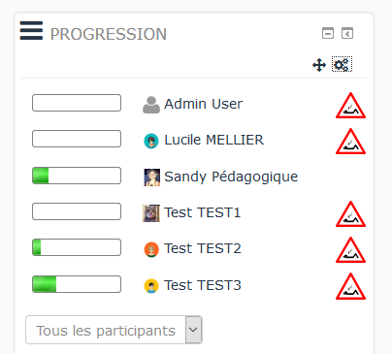

Add blokc on a course
Switch to Edit mode using the button under your login name.
Drop-down menu Add Block / Summary of learning times

Block settings
- Title : Default : Progress, but you can add another one.
- Choose a learning time list : Choose in the drop-down list of which LTC (Module learningtimecheck) you want to display.
- Choose a groupe : Defaut none.
- Stall signal : None, one week, two weeks, three weeks,1 month.

Credits
- Valéry Frémaux (valery@activeprolearn.com)- Conception and developments
- Florence Labord (florence@activeprolearn.com) : Documentation
———-
Back to Learning Time Check block index - See Learning Time Check component - Back to plugins index - Back to catalogue

