

Course Ascendants Block
- Component type: Block
- Name: Course Ascendants
- Family: Navigation
- Versions: to
- Older versions: 1.9, 2.2 à 2.6
- Distribution : Public and PRO
- Availability: Stable
- Repository: https://github.com/vfremaux/moodle-block_course_ascendants
- GPDR Compatibility: >= 3.4.2
LIVE ActiveProLearn course
This block is an accessory to help with metacourse binding strategies, and was designed to simplify and facilitate enrolment dépendancies between several courses.
Meta course reminder
This block is useful for teachers who intend to quickly activate or desactivate a module (metacourse) in a cursus (course where the block is implemented) from a set of courses (available metacourses) selected from the chosen course category.
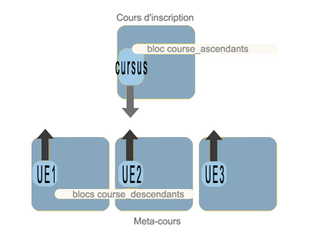

Guides
- Install guide
- User guide
- Technical guide

Associated plugins
- Course Ascendants block can be used appaired with Course Descendants blocks added to course submodules. Both blocks will provide a full consistant intercourse navigation principle.

Features
- Course submodules location selection (as a category)
- Quick submodule binding/unbinding
- Nice course submodules summary with completion indicator
- Hide/show course category names
- Automated group creation on binding representing the source master course

Builds
Travis-ci Continuous integration
Note : Failing status is not necessarily the sign of a non functioning module. It just says that the Moodle code standards check are not full filling. This is a continuous effort of us rewriting the plugin code to get it compliant.

Credits
- Valéry Frémaux (valery@activeprolearn.com)- Developments and tests
- Florence Labord (florence@activeprolearn.com) : Documentation and fonctionnal review

Back to plugins index - Back to catalogue index

