

Block Shop Access (Sales department) : User guide

Moodle Integrated Online Store

Introduction
Any people enabled to can add a Sales departement block to the home page, the dashboard page or any course page by adding a Sales services instance. If you started several shop instances in the same Moodle, you may setup one Sales services block per instance.

Access
Add block named “Sales department” dans un cours qui sert de support client par exemple ou un espace de cours de votre choix de la plateforme Moodle.
Path : Site Administration/Add a block/Sales department service(Shop Access)
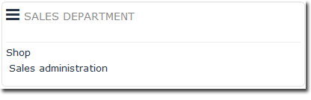

Sales department block menu

1/Shop
Link to Shop, in frontoffice mode (customer view) or backoffice (for users with access permissions).

2/Sales administration
This link to access to :
- Catalog management
- Sales management links list for users with access permissions
Illustration : Sales services page
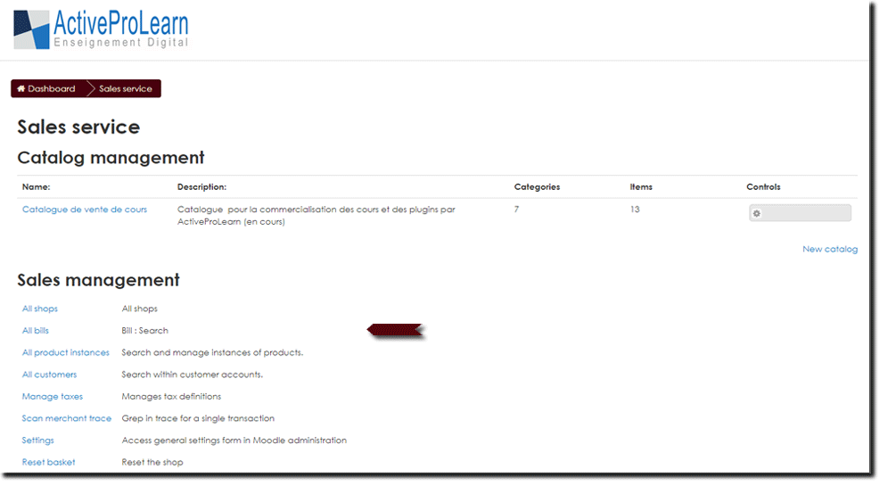

Back to component index- setup a commercial offer in moodle -Back to componant Local Shop - Revenir au catalogue

