

Block : Self Check In - QrCode display for self check in : User guide

Pedagogical scenario
Remotely, the teacher sends an image of the QR code to students via email or SMS.
Alternatively, in a face-to-face setting (using an interactive whiteboard, projection screen, or monitor), the teacher displays the QR code associated with the lesson to the students.
Learners scan the QRCode with their mobile device and are redirected to an sign-in form. They can directly create their account on the mobile, without the need for validation by email (email remains requested as mandatory information to create the account). An identification (login) in the email format in this case will be preferred, to avoid identifier collision issues with existing identifiers.

Using the block
- As a teacher, place the block on your course.
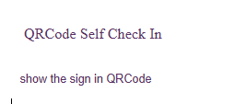
- Display it in class to present it to the students present.
- Students scan the QR code and are redirected to a check-in form where they can quickly create an account.
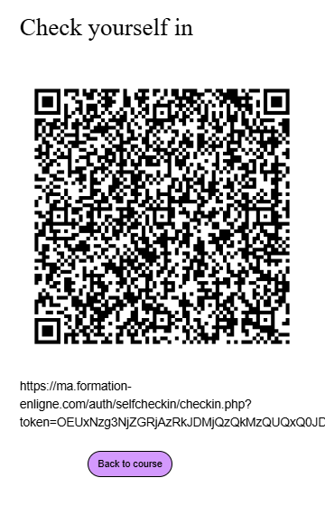

Back to plugin block self check in index - Back to plugins summary - Back to catalogue

