

Availability condition Week : User guide

User guide Restrictions by week from start
Usual restrictions in activity settings, just choose week
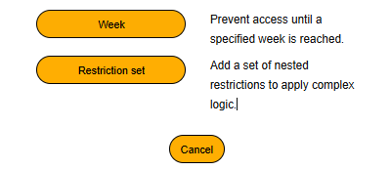
Then choose option, depending global setting for the plugin (See technical guide)
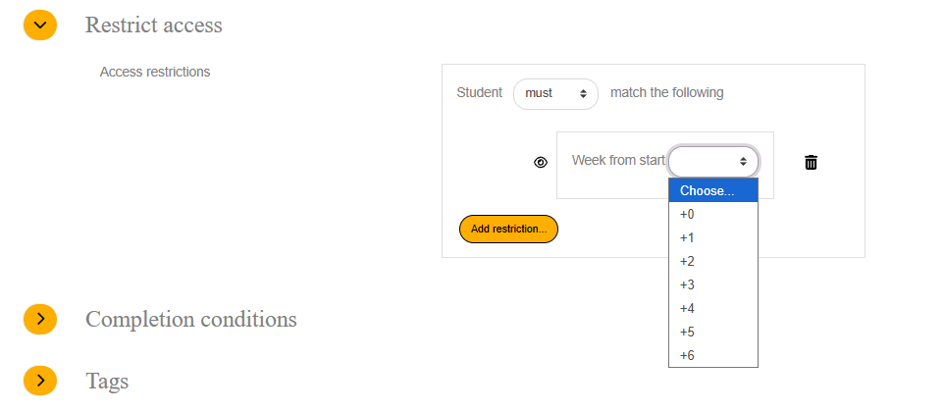

Credits
- Valéry Fremaux : development
- Florence Labord : Documentation & tests
Back to home - Return to the plugin index

