

Availability condition : Week

Technical guide Restrictions by week from start
Access to Administration/plugins/Availability restriction/Restrictions by week from start
Choose the default reference between :
- The course start date : In that case the cutoff date for the controlled item is absolute and identical for all students.
- The date of the user's enrolment : In that case the cutoff date will be relative for each student individually and equally.
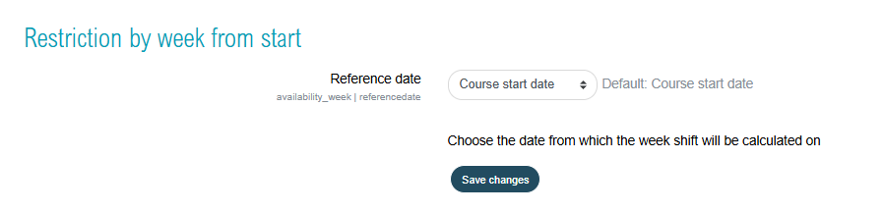

Credits
- Valéry Fremaux : development
- Florence Labord : Documentation & tests
Back to home - Return to the plugin index

