

Self Check In auth - QRCode self check in authentication user Guide

Guide
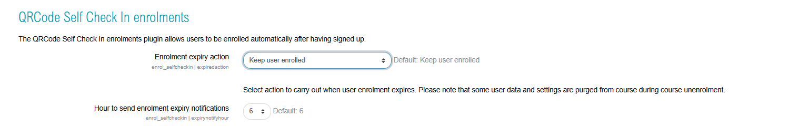

Go to Self check in auth index - Back to plugins summary - Back to catalogue

